Insulated Gate Bipolar Transistor (IGBT)

The IGBT is a voltage controlled transistor switch that has become the dominant switching technology for power electronic circuits at voltage levels from 200V to several thousand volts.

Circuit Symbol of N-Channel IGBT

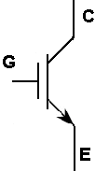
Collector

Gate

Emitter

Simplified Equivalent Circuit

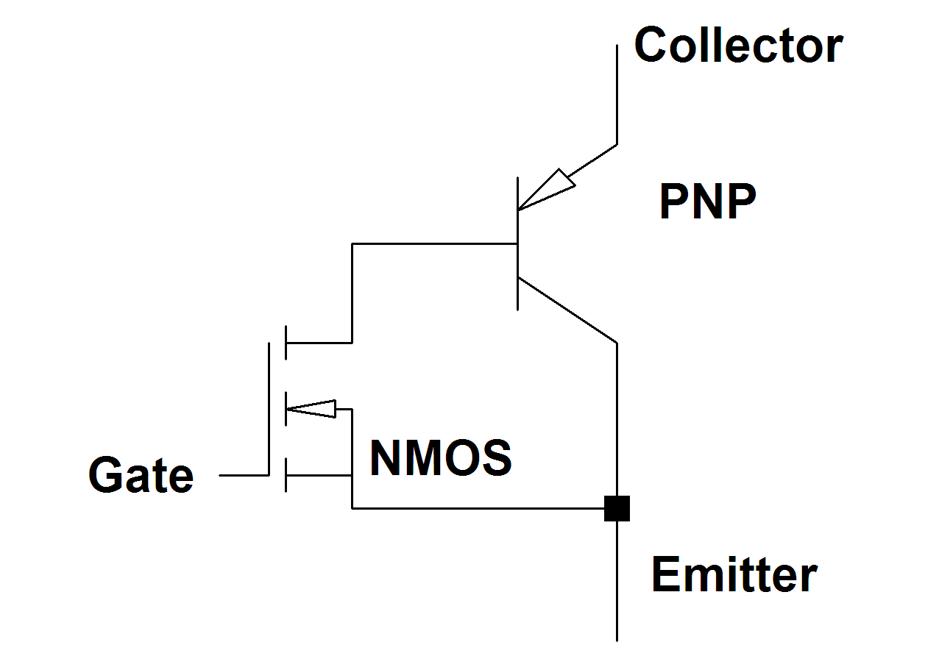
Operation of the IGBT

In use the collector is a positive voltage compared to the emitter and the path of main current flow is from collector to emitter.

When the gate-emitter voltage is zero or negative the IGBT is off and no current flows from collector to emitter.

When a small positive voltage (Typically 10V-15V) is put on the gate-emitter the igbt turns on and allows conduction from collector to emitter.

The input behaves like the gate of a mosfet with high input impedance and a capacitive characteristic.

The output behaves like a bipolar transistor with high voltage / high current capability.

Due to charge storage in the bipolar stage IGBTs are inherently slower than mosfets with typical maximum switching frequencies of a few 10’s of kHz.

An IGBT in its on state does not have a resistive characteristic like a mosfet. Its V-I characteristic is non-linear but for a given silicon die size a high voltage IGBT has a lower on state voltages that high voltage mostfets at the same current levels. For this reason IGBTs are more cost effective than mosfets at system voltages of above 200V.

High Power IGBTS are almost always packaged with a reverse diode. This is needed as a freewheel diode in bridge applications. Unlike the intrinsic body diode of a mosfet this diode can be made as fast as required.

Although some complementary P-Channel IGBTs are available they are generally undesirable and N-channel IGBTS are almost always used.

